PRIMENA FMEA U AUTOMOBILSKOJ INDUSTRIJI: TRENUTNA SITUACIJA I PERSPEKTIVE U REPUBLICI SRBIJI

Autor | Ustanova | E-mailAutor | Ustanova | E-mail

APPLICATION OF FMEA IN THE AUTOMOTIVE INDUSTRY: PRESENT SITUATION AND PERSPECTIVES IN THE REPUBLIC OF SERBIA

*Sažetak*

U okviru ovog rada izvršena je analiza primene FMEA u preduzećima automobilske industrije koja posluju na teritoriji Republike Srbije, sa fokusom na trenutnu situaciju i buduće perspektive. Prikazane su osnovne karakteristike primene ove analize, kao što je broj zaposlenih koji je uključen u proces implementacije, kao i zastupljenost različitih tipova FMEA u razmatranim preduzećima. Osim toga, u istraživanju su predstavljene i analizirane potrebe za metodološkim unapređenjima i primenom modernih alata u sprovođenju FMEA. Cilj ovog istraživanja je da predstavi trenutnu situaciju i probleme u primeni FMEA u automobilskoj industriji u Republici Srbiji, ali i da ukaže na mogućnosti za buduća unapređenja.

*Abstract*

This paper conducts an analysis of the application of FMEA in companies operating in the automotive industry within the territory of the Republic of Serbia, focusing on the current situation and future perspectives. The basic characteristics of implementing this analysis are presented, such as the number of employees involved in the implementation process and the prevalence of different types of FMEA in the considered companies. Additionally, the study presents and analyses the needs for methodological improvements and the adoption of modern tools in conducting FMEA. The aim of this research is to present the current situation and challenges in the application of FMEA in the automotive industry in the Republic of Serbia, as well as to identify possibilities for future improvements.

***Ključne reči:*** *FMEA, trenutna situacija, buduće perspektive, automobilska industrija, Republika Srbija*

*Keywords: FMEA, current situation, future perspectives, automotive industry, Republic of Serbia*

Introduction

Risk and reliability management are crucial for the operations of companies in the automotive industry, especially concerning ensuring the required level of product quality and production process. Failure Mode and Effect Analysis (FMEA) is a method used for this purpose in all automotive industry companies, and its application is obligated by international standard [1]. However, FMEA is applied with certain variations and the use of different approaches from company to company. The introduction of the new AIAG & VDA Handbook [2] has added complexity to FMEA implementation, as it significantly changes the risk assessment methodology compared to all previous approaches. Therefore, companies are currently in the process of transition, moving from the old to the new approach. Furthermore, the method's application itself, employee involvement, risk assessment approach, and the use of new technologies for this purpose significantly vary from one company to another.

The aim of this paper is to analyse the current application of FMEA in the automotive industry in the Republic of Serbia, with a focus on current trends in the application of new technologies and tools in its implementation. After the introductory and the literature review chapter, the second chapter presents an analysis of FMEA application in terms of employee involvement and types of FMEA used. Chapter 3 explains the additional needs and application of modern tools in FMEA implementation, while Chapter 4 provides conclusions.

Although the application of FMEA is primarily characteristic of the automotive industry, it is also implemented in many other industrial sectors where there is a need for it. This is particularly the case in industries requiring high precision and reliability of parts and constructions. For example, in [3], the authors use FMEA to assess the reliability of offshore wind turbines, in [4] for the reliability assessment of aircraft landing systems, while in [5] FMEA is used in software failure analysis problem. Additionally, FMEA is used in various sectors of the manufacturing industry, with different modifications and adaptations to the considered problem [6].

As known, FMEA can fundamentally be applied in three ways [2]: 1) Process FMEA (PFMEA), Design FMEA (DFMEA), and FMEA for monitoring and system response (FMEA-MSR). In the relevant literature, the majority of studies are focused on the application and improvement of PFMEA [7, 8, 9]. Additionally, DFMEA analysis has been applied in a certain number of studies [10, 11], while FMEA-MSR has been used very rarely [12].

Authors often address the inaccuracies and uncertainties existing in FMEA problems by modeling them through the application of various fuzzy sets [5, 7, 8, 13], as well as through the use of Multi-Attribute Decision-Making (MADM) methods. The most commonly used MADM methods to enhance FMEA analysis include the Analytic Hierarchy Process (AHP) [3, 14, 15], and the Technique for Order Preference by Similarity to Ideal Solution (TOPSIS) [14, 16, 17]. However, such methodological modifications of FMEA analysis in practice are very rare. Primarily due to the complexity of the proposed models and the insufficient knowledge of FMEA teams. It should be emphasized that in the relevant literature, significant consideration has been given to the integration of smart technologies into FMEA analysis, aiming to adapt this method to the trends of Industry 4.0 [18, 19, 20].

Although there are numerous studies where FMEA has been applied in the automotive industry as well as in other industrial sectors, none of them address the analysis of the method's application in terms of its prevalence, variations from company to company within a country or industry sector, and similar aspects. The authors have exclusively focused on solving specific issues through case studies. For this reason, this paper conducts such an analysis for companies in the automotive industry operating within the territory of the Republic of Serbia.

BASIC CONSIDERATIONS ON IMPLEMENTING FMEA IN THE AUTOMOTIVE INDUSTRY IN THE REPUBLIC OF SERBIA

The research presented in this chapter was conducted on a sample of 46 companies. The considered companies manufacture various products and are part of supply chains within the automotive industry. What is common to all these companies is that they have a production facility within the territory of the Republic of Serbia.

* 1. Examining the dependence between the total number of employees in a company and the number of employees involved in the implementation of FMEA analysis

As companies have different numbers of employees, use varying technologies in product manufacturing, as well as different materials and production processes, they also have different requirements regarding the application of FMEA analysis. Primarily, a significant difference among the companies lies in the number of employees directly involved in conducting FMEA analysis. In order to examine the existence of a dependency between the total number of employees in a company and the number of employees involved in the implementation of FMEA analysis, a procedure for testing dependency using a contingency table was applied. The problem setting is depicted in Table 1.

Table 1. Number of companies by categories: Total number of employees/Number of employees involved in FMEA implementation

|  |  |  |  |  |  |  |
| --- | --- | --- | --- | --- | --- | --- |
|  | | Number of employees involved in FMEA implementation | | | | |
| <5 | 6-10 | 11-20 | 21-50 | >50 |
| Total number of employees | <50 | 3 | 0 | 1 | 0 | 0 |
| 51-250 | 5 | 1 | 3 | 1 | 0 |
| 251-500 | 4 | 3 | 1 | 0 | 0 |
| 501-1000 | 1 | 8 | 2 | 2 | 0 |
| >1000 | 2 | 1 | 1 | 6 | 1 |

Next, the procedure for testing the hypothesis is carried out through the following steps:

Step 1. Formulation of hypotheses: $H_{0}$: The total number of employees in the company and the number of employees involved in the implementation of FMEA are two mutually dependent variables, and $H_{1}$: are not two mutually dependent variables.

Step 2. A standard risk level of 5% has been adopted.

Step 3. Decision statistics: $χ^{2}=30.7$

Step 4. Criterion for rejecting the null hypothesis, $H_{0}$: $χ^{2}>χ_{α,v}^{2}→χ^{2}>χ_{0.05,16}^{2}$

Step 5. Decision: $χ_{0.05,16}^{2}=26.3$. The assertion is being examined: $30.7>26.3$

As the stated assertion is correct, it can be concluded that the condition for rejecting the null hypothesis H₀ is met. In other words, hypothesis H₁ is accepted. This means that the total number of employees in the company and the number of employees involved in the implementation of FMEA analysis are not two mutually dependent variables.

Based on the obtained results, it can be concluded that companies still do not fully comprehend the significance of FMEA analysis and implement it merely as a mandatory procedure prescribed by the standard. Similarly, through organizational structure planning, companies attempt to optimize the number of employees, thereby influencing the count of members in the FMEA team.

* 1. Prevalence of different types of FMEA

Depending on the application domain, various forms or types of FMEA analysis exist. In the analysed companies, three forms of FMEA analysis are represented: 1) Design FMEA, 2) Process FMEA, and 3) Maintenance FMEA. The frequency of their representation is depicted in Figure 1.

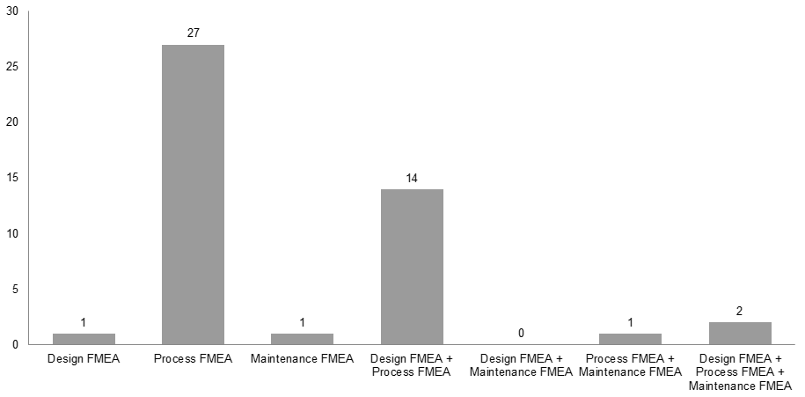

*Figure 1. Representation of different forms of FMEA in the considered companies*

From Figure 1, it is evident that Process FMEA is the most prevalent form of FMEA analysis in the considered companies. Additionally, a significant number of companies apply both Design FMEA and Process FMEA. The absolute ratio of representation for different forms of FMEA analysis is illustrated in Figure 2.

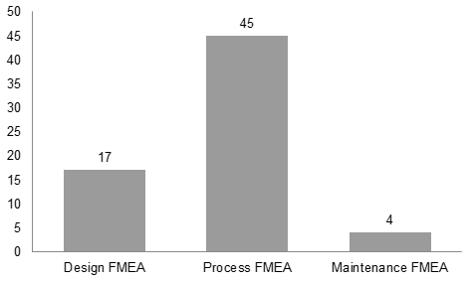

*Figure 2. Overall Representation of Different Forms of FMEA Analysis in the Considered Companies*

As evident from Figure 2, 45 out of the 47 considered companies implement Process FMEA. Therefore, it can be considered the most widespread and significant form of FMEA. Just above one-third of the total number of companies, specifically 17, apply Design FMEA analysis, while Maintenance FMEA is employed in only 4 companies.

* 1. Method of determining the priority of failure modes

Depending on whether the FMEA teams of the companies have undergone training on the transition from the AIAG Manual to the VDA & AIAG Handbook [2], different approaches in determining the priority of failure modes may vary. Figure 3 illustrates the approaches represented in the considered companies.

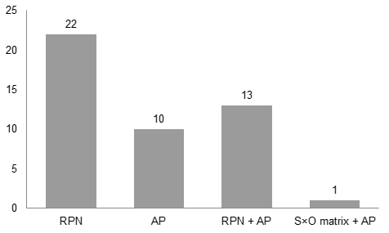

*Figure 3. Approaches in determining the priority of failure modes*

Upon reviewing the records, it can be concluded that the majority of companies still use RPN for determining the priority of failure modes. Specifically, 22 companies exclusively use RPN, while 13 companies use both RPN and AP. This indicates that companies using only RPN are still following the AIAG Manual. Additionally, one company does not use the traditional RPN but determines the priority of failure modes through the product of risk factors S and D, and it also employs the AP methodology. This means that even 14 companies are still in the transition process, using both approaches concurrently. On the other hand, 10 companies have fully transitioned to the AP methodology and operate according to the new VDA & AIAG Handbook [2].

1. ADDITIONAL NEEDS AND APPLICATION OF MODERN TOOLS IN FMEA IMPLEMENTATION
   1. Requirements and needs in FMEA implementation

In addition to expertise, effective problem analysis, and decision-making based on analysis, FMEA also involves the implementation of a lengthy and complex administrative procedure. Indeed, FMEA teams may have various requirements and needs in this domain. Within this research, five requirements expressed by respondents were analysed, the fulfilment of which would significantly contribute to simplifying the application of FMEA, at least in a technical or administrative sense. The demands expressed by representatives of FMEA teams are:

* Option 1: Streamlined definition of Severity (S), Occurrence (O), and Detection (D) risk indices and prioritization without using tables from the Handbook;
* Option 2: Feature for defining costs of failure modes, improvement costs, statistical tracking of cost growth, and assistance in decision-making and return on investment calculations;
* Option 3: Decision-making on priority risks (with expanded priorities that include financial aspects, customers, product importance, cause frequency, safety, time, etc.);
* Option 4: Use of a mobile phone/tablet for managing FMEA analysis;
* Option 5: Use of notifications within the FMEA analysis about significant changes (when someone takes action, when risk changes, etc.).

Respondents expressed their opinions on a scale of [1-5] regarding how significant each of the identified options would be for their FMEA team and the company as a whole. A rating of 1 means that the option is not important to them, while a rating of 5 means that the introduction of the option is of utmost importance. Figure 4 shows the average rating each option received from the respondents.

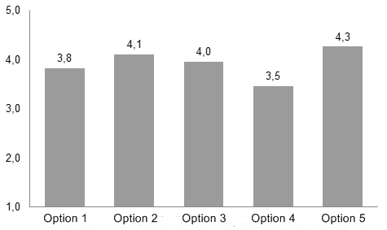

*Figure 4. Average rating for each considered option*

Based on the collected data, summarized in Figure 4, it can be concluded that Option 5 received the highest average rating, while Option 2 ranked second. Therefore, it can be said that FMEA teams find it most important and necessary to have an updated database that changes and supplements automatically. This facilitates the reuse of FMEA for the purpose of its revision. It can also be inferred that all the considered options were relatively well-rated, but, in addition to the mentioned two, Option 3 was also very interesting to the respondents.

The analysis of the collected results can also be viewed from another perspective. Figure 5 shows the average interest of companies in the considered options when classified according to the total number of employees in the company.

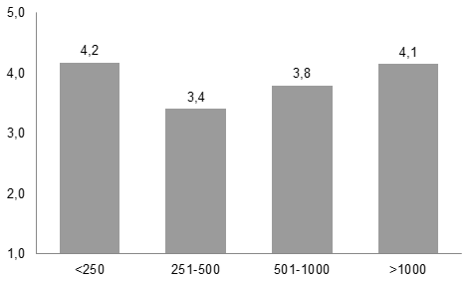

*Figure 5. Average rating for the considered options depending on the total number of employees in the company*

Examining the histogram shown in Figure 5, it can be concluded that companies with fewer than 250 or more than 1000 employees show a greater interest in the implementation of the considered options. This information may suggest that smaller companies, with more flexible structures and quicker decision-making processes, as well as larger companies, with more resources for implementing changes, exhibit more interest in improvement and the introduction of new elements into the FMEA analysis process. This is just one interpretation, and the final conclusion depends on additional information and the context of the research.

By applying correlation analysis, it has been determined that there is a significant dependence between certain ratings at the company level. For instance, between Option 1 and Option 3, the correlation coefficient is $r=0.77$, while between Option 3 and Option 5, it is $r=0.73$. This essentially means that there is a high likelihood that a change in ratings for one of the considered options at the company level causes a change in the rating of another considered option. The reverse is also true. For example, the rating value for Option 3 follows the trend of changing the rating value for Option 5, and vice versa.

* 1. Implementation of additional and smart options in conducting FMEA analysis

In the midst of the development of smart technologies and the application of Industry 4.0 concepts, companies are attempting to adapt to modern trends. However, in the implementation of FMEA analysis, companies in the Republic of Serbia still rely on traditional tools, most commonly Microsoft Excel. Figure 6 illustrates the prevalence of software used for conducting FMEA analysis in the automotive industry in the Republic of Serbia.

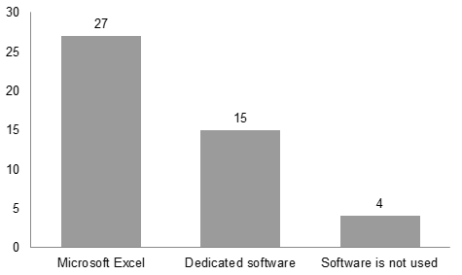

*Figure 6. Used FMEA software*

From the attached information, it can be seen that about one-third of the considered companies have dedicated software for implementing FMEA analysis. Four companies do not use any software at all, not even Microsoft Excel, but instead, they perform FMEA analysis manually (on paper). This fact indicates that the application of FMEA analysis in the Republic of Serbia is still based on a traditional approach and does not heavily rely on smart tools.

The following analysis was conducted exclusively for companies that have dedicated FMEA software. In response to the question "Does the software provide support in assessing the value of risk factors?", 8 companies answered "Yes" and 7 answered "No". As for the question "Does the software have additional smart tools for cost analysis, tracking statistical parameters, and providing suggestions for prescribing actions?", only 2 companies responded "Yes" while 13 responded "No".

Based on this fact, it can be concluded that even companies using dedicated FMEA software very rarely utilize additional or smart options. About half of the companies use tools to support the assessment of risk factor values, while only two companies use software that includes additional analysis options. What should be added is that one company has a version of FMEA software on Android and tablet, while another company has this option for Android. This indicates that there is space for improvement, and at this moment, the implementation of FMEA analysis is not sufficiently aligned with technological advancements.

1. CONCLUSION

In this study, the application of FMEA in companies operating within the automotive industry in the Republic of Serbia has been analysed, providing insights into the current situation and future perspectives. The presented results indicate that there is space for improvement in terms of more efficient implementation and broader application of various types of FMEA. Additionally, the research has identified the need for methodological enhancements and the use of modern tools to enhance the risk analysis process.

The conclusion is that adaptation of the FMEA methodology to changes in industrial trends, including new technologies and regulations, is necessary. Moreover, it is clear that further implementation of advanced tools and strategies, such as digitization and the application of artificial intelligence could significantly enhance the efficiency of FMEA in the automotive industry of the Republic of Serbia.

Also, this research provides a basis for further investigation and improvement of FMEA implementation in the automotive industry of the Republic of Serbia. Future research directions could focus on analysing FMEA application in other countries, enabling comparison of the obtained results with this analysis.

**References**

1. IATF 16949:2016, ‘Quality management system requirements for automotive production and relevant service parts organizations, 1st edition’. International Automotive Task Force, 2017.
2. AIAG&VDA, Failure Mode and Effects Analysis - FMEA Handbook: design FMEA, process FMEA, supplemental FMEA for monitoring & system response. Southfild, Michigan: Automotive Industry Action Group, 2019.
3. Li, He, Angelo P. Teixeira, and C. Guedes Soares. "A two-stage Failure Mode and Effect Analysis of offshore wind turbines." Renewable Energy 2020., 162, pp. 1438-1461.
4. Yazdi, M., Sahand D., and Hashem S.. "An extension to fuzzy developed failure mode and effects analysis (FDFMEA) application for aircraft landing system." Safety science 2017., 98, pp. 113-123.
5. Ðurić, G., Mitrović, Č., Komatina, N., Tadić, D., & Vorotović, G. The hybrid MCDM model with the interval Type-2 fuzzy sets for the software failure analysis. Journal of Intelligent & Fuzzy Systems, 2019., 37(6), pp. 7747-7759.
6. Wu, Z., Liu, W., & Nie, W. Literature review and prospect of the development and application of FMEA in manufacturing industry. The International Journal of Advanced Manufacturing Technology, 2021., 112, pp. 1409-1436.
7. Komatina, N., Tadić, D., Aleksić, A., & Banduka, N. The integrated PFMEA approach with interval type-2 fuzzy sets and FBWM: A case study in the automotive industry. Proceedings of the Institution of Mechanical Engineers, Part D: Journal of Automobile Engineering, 2022., 236(6), pp. 1201-1212.
8. Aleksić, A., Milanović, D. D., Komatina, N., & Tadić, D. Evaluation and ranking of failures in manufacturing process by combining best‐worst method and VIKOR under type‐2 fuzzy environment. Expert Systems, 2023., 40(2), pp. 13148.
9. Oliveira, C. R. C. D., Pereira, J. C., & Pizzolato, N. D. Combined application of condition-based maintenance and reliability centred maintenance using PFMEA and lean concepts-a case study. International Journal of Information and Decision Sciences, 2023., 15(3), pp. 302-325.
10. Aguirre, P. A. G., Pérez-Domínguez, L., Luviano-Cruz, D., Gómez, E. M., Olguin, I. J. C. P., & Ramírez, J. O. D. Risk assessment with value added Pythagorean fuzzy failure mode and effect analysis for stakeholders. IEEE Access, 2021., 9, pp. 149560-149568.
11. Zhou, J., Liu, Y., Xiahou, T., & Huang, T. A novel FMEA-based approach to risk analysis of product design using extended Choquet integral. IEEE Transactions on Reliability, 2021., 71(3), pp. 1264-1280.
12. Rajasimha, R. C., Arjun, V., & Chandrashekhar, H. G. Supplemental FMEA for Monitoring and System Response of Electronic Power Steering Control System Functional Safety (No. 2022-28-0404). SAE Technical Paper, 2022.
13. Fu, Y., Qin, Y., Wang, W., Liu, X., & Jia, L. An extended FMEA model based on cumulative prospect theory and type-2 intuitionistic fuzzy VIKOR for the railway train risk prioritization. Entropy, 2020., 22(12), pp. 1418.
14. Zandi, P., Rahmani, M., Khanian, M., & Mosavi, A. Agricultural risk management using fuzzy TOPSIS analytical hierarchy process (AHP) and failure mode and effects analysis (FMEA). Agriculture, 2020., 10(11), pp. 504.
15. Kumar, M. B., & Parameshwaran, R. A comprehensive model to prioritise lean tools for manufacturing industries: A fuzzy FMEA, AHP and QFD-based approach. International Journal of Services and Operations Management, 2020., 37(2), pp. 170-196.
16. Başhan, V., Demirel, H., & Gul, M. An FMEA-based TOPSIS approach under single valued neutrosophic sets for maritime risk evaluation: the case of ship navigation safety. Soft Computing, 2020., 24(24), pp. 18749-18764.
17. Kumar, P., Raju, N., Navaneetha, M., & Ijmtst, E. Reliability analysis of dumpers through FMEA-TOPSIS integration. International Journal for Modern Trends in Science and Technology, 2021., 7(09), pp. 110-8.
18. Webert, H., Döß, T., Kaupp, L., & Simons, S. Fault handling in industry 4.0: definition, process and applications. Sensors, 2022., 22(6), pp. 2205.
19. de Andrade, J. M., de M. Leite, A. F. S., Canciglieri, M. B., Szejka, A. L., de FR Loures, E., & Canciglieri, O. A multi-criteria decision tool for FMEA in the context of product development and industry 4.0. International Journal of Computer Integrated Manufacturing, 2022., 35(1), pp. 36-49.
20. Salah, B., Alnahhal, M., & Ali, M. Risk prioritization using a modified FMEA analysis in industry 4.0. Journal of Engineering Research, 2023., 11(4), pp. 460-468.